**Bohr Diagrams & Valence Electrons Worksheet** Name: ________________________________

*Background:*

Bohr Diagrams are models to show where the electrons are located in regards to the energy levels. Remember, electrons are not orbiting the nucleus like the earth does the sun. But instead, think of them as being located in a region outside the nucleus. What region they are located in is based off of their energy, and we refer to these regions as energy levels. Each energy level has a maximum amount of electrons that it can hold (it can hold less than that amount, but no more). The maximum amount of electrons for each energy level is as follows…

1st energy level: 2 electrons

2nd energy level: 8 electrons

3rd energy level: 8 electrons (for the first 20 elements, after calcium those elements can hold 18 in the 3rd level)

4th energy level: 18 electrons (after strontium the max goes up to 32, but we’re not going there.)

For the following examples, use the above information to help you find the total number of electrons, the number of electrons in each energy level, then draw your Bohr diagrams in the space provided. Finally, you need to identify the Outer energy level and valence number.

Outer energy level = ___ valence. # = ___

**nitrogen (N) #7**

Total number of electrons =____

How many electrons in each energy level?

1st___ 2nd___ 3rd___ 4th___

3.

Outer energy level = ___ valence. # = ___

**magnesium (Mg) #12**

Total number of electrons =____

How many electrons in each energy level?

1st___ 2nd___ 3rd___ 4th___

2.

Outer energy level = ___ valence. # = ___

**sodium (Na) #11**

Total number of electrons =____

How many electrons in each energy level?

1st___ 2nd___ 3rd___ 4th___

1.

Draw it… Draw it… Draw it…

Outer energy level = ___ valence. # = ___

**argon (Ar) #18**

Total number of electrons =____

How many electrons in each energy level?

1st___ 2nd___ 3rd___ 4th___

6.

Outer energy level = ___ valence. # = ___

**fluorine (F) #9**

Total number of electrons =____

How many electrons in each energy level?

1st___ 2nd___ 3rd___ 4th___

5.

Outer energy level = ___ valence. # = ___

**neon (Ne) #10**

Total number of electrons =____

How many electrons in each energy level?

1st___ 2nd___ 3rd___ 4th___

4.

Draw it… Draw it… Draw it…

Outer energy level = ___ valence. # = ___

**Gallium (Ga) #31**

Total number of electrons =____

How many electrons in each energy level?

1st___ 2nd___ 3rd___ 4th___

9.

Outer energy level = ___ valence. # = ___

**What element is it?___________**

Total number of electrons =____

How many electrons in each energy level?

1st___ 2nd___ 3rd___ 4th___

8.

Outer energy level = ___ valence. # = ___

**What element is it?___________**

Total number of electrons =____

How many electrons in each energy level?

1st___ 2nd___ 3rd___ 4th___

7.

**Follow up questions relating Bohr Diagrams to Periodic Trends and Valence Elections**

1. Choose 2 elements with the same number of valence elections.
2. What other elements from the periodic table would have the same number of valence electrons as the ones you chose in #1.
3. Phosphorus is in the same group as nitrogen, how many valence electrons would you predict Phosphorus to have?
4. Using the information from the Bohr diagrams from above, label the periodic table below with the number of valence electrons for each of the main group elements.

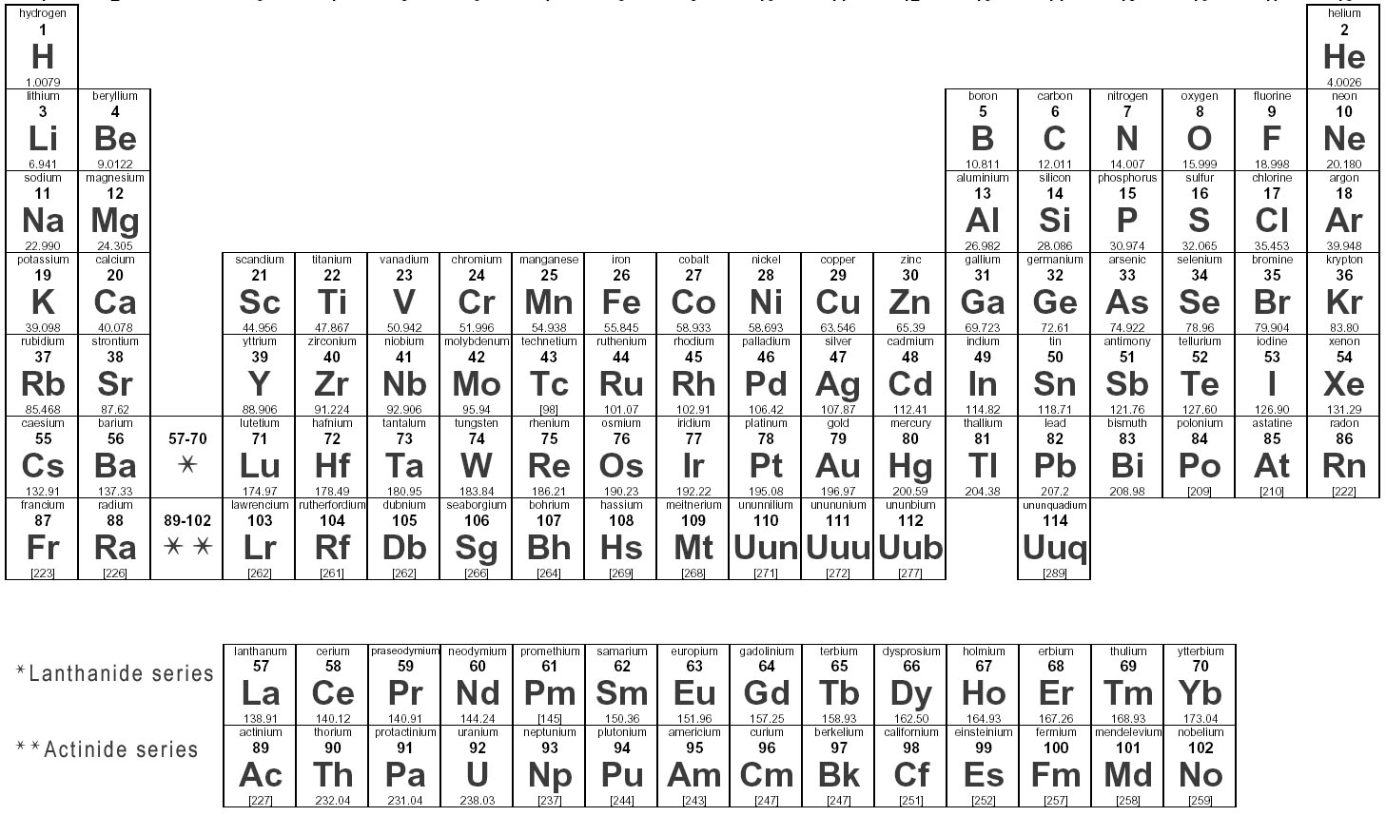 __ __ __ __ __ __ __ __

# of valence electrons